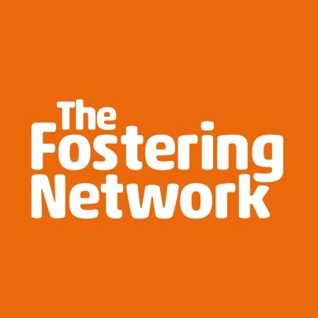

Young people, savings and financial education

The Fostering Network has identified free resources available to help children and young people in care to build their knowledge and confidence with money. The resources below deliver effective, relevant and age-appropriate financial education to children in care and young people about to leave care.

Family Workshop

This resource is for all care professionals working with families, carers and guardians of children of primary and secondary school age.

The workshop focuses on helping families explore money learning together. Parents/carers will discover ways to include their children in everyday discussions and actions related to money thereby improving both their children’s financial capability and in turn, their own too. The content is adaptable for parents/carers with children of any age and contains activities that are easily deliverable by noneducators and non-financial education experts.

Money Heroes resources

This resource is for use with primary school aged children and can be used by virtual schools/designated teachers, carers and guardians.

The Money Heroes online platform uniquely brings together the teacher and carers/guardians, enabling them to work together to support the child’s financial capability. A wide range of tools and resources can be found for free on the platform including activities for school and home, a series of books covering different money themes, a parent/carer guide to financial education, a podcast series for parents (including input form Sir Chris Hoy and Dame Sarah Storey), and lots more.

Developing Financial Futures

This resource is for use with young people in secondary and post-16 education by virtual schools/designated teachers, carers and guardians.

It contains easily adaptable and discussion-based activities coving the following themes: Receiving a Windfall; Shopping Deals; Moving on to Further Education or Training; A Place of my Own; Taking Priority; Debt and Borrowing; Getting Advice.

Your Money Matters Financial education textbook

This resource is aimed at secondary school aged children and those in post-16 education to be used by virtual schools/designated teachers, carers, guardians and young people.

The ‘Your Money Matters’ textbook, supported by the Department for Education, has been designed for use with young people aged 14-16 and covers topics including spending and saving, borrowing, debt, insurance, student finance and future planning. It can be used as a tool to support educators and carers as well as for self-led learning by young people.

Making Your Money Work for You

Two resources have been developed to be used by Virtual schools/Designated teachers, Carers, Guardians with young people aged 11+.

These two workbooks have been designed to support children in care aged 11-14 and aged 15+ to develop their financial capability through a combination of information and activities. These can be worked through independently or together with an educator or carer.

Spending Sense

This resource is aimed at children of secondary school age, post-16 and those with special educational needs and can be used by virtual schools/designated teachers, carers and guardians.

A flexible resource aimed at those working with young people with mild to moderate special educational needs. All of the activities within the resource are easily differentiated according to needs and ability of the young people. Through practical activities and a use of simplified text this resource covers a wide range of financial topics aimed at the transition towards independent living.

Advisory Service

This resource is for anyone working to develop the financial capability of children and young people.

A dedicated support line to provide answers to ANY of the questions around the development and delivery of financial education to young people. The service is free, and there is a team of expert staff to help answer questions or just signpost to further support and advice if needed.

The Share Foundation also has a range of useful resources including,

Stepladder of Achievement

This resource is for virtual schools/designated teachers, social workers, carers, guardians to use with young people aged 15-17.

A six-step program for building life skills of young people in care aged 15 to 17: incorporating literacy, numeracy and financial education. It is available throughout the United Kingdom in its standard form; but with the co-operation of local authorities providing a financial contribution, an enhanced version 'Stepladder Plus' can be offered to young people in care from those areas. In this version, the young person can 'earn' up to an additional £1,500 by completing all 6 modules, which is paid into their Junior ISA account, which they can access at age 18. If you are interested in offering the incentivised version, please speak to the Share Foundation.

Young Scot

Young Scot has a range of tips and tools to help young people with savings and money matter. Visit: Saving - Young Scot

Dosh

Dosh supports people with a learning disability to be able to manage their money. As part of the Thera Group working across England, Wales and Scotland, they provide financial advocacy, appointeeship for benefits and account management for self-directed support budgets. Dosh – Financial Advocacy

Last updated: June 2022

