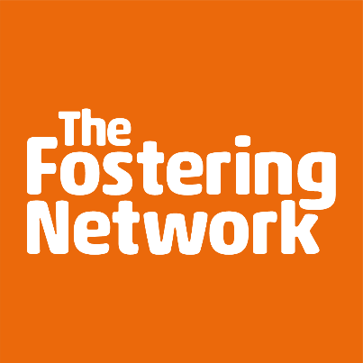

Open training course booking form
It is easy to book a place on one of our open courses. Please complete and return this booking form to Joy Crawford, Learning & Development Co-ordinator.
Email: joy.crawford@fostering.net.
For further information on any of our open courses, please don’t hesitate to get in touch. Call 0141 204 1400 or email joy.crawford@fostering.net.
The training will be delivered via zoom with a mixture of presentation and trainer guided exercises throughout. All participants will need a stable internet connection with a camera and microphone.
Course(s) you would like to attend:
Name(s):
Address:
Designation:
Daytime tel:
Email address:
Invoice to (name and address please):  Purchase Order No:  Telephone:  E-mail: | (Please ensure that any training you may wish to attend has been authorised by your local authority/agency)
Fees for members of The Fostering Network incorporate a 50% discount. Please ensure that course participants have an up-to-date membership in order to take advantage of this discount. All fees are exclusive of VAT. Please note should you wish to cancel a place, you must do so four weeks prior to the course date. Cancellations made less than four weeks up to the date of training will be invoiced. As we are in unpredictable times in relation to COVID19, training courses could be affected/cancelled at short notice and therefore any training would be postponed until a further date and you would be advised accordingly.

