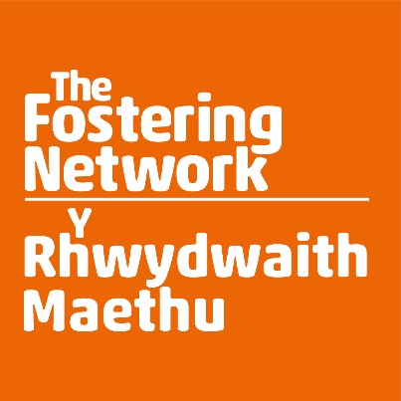

Professional Development in Fostering: Personal Reflective Journal

This journal should be completed following attendance at a Fostering Network in Wales training event and is part of our blended learning approach, which combines online learning and face-to-face learning in groups with self-guided research and reflection.
The journal supplements the Post Approval Training Framework Record of Ongoing Learning and Development, which foster carers should use to capture evidence of learning and share with their supervising social worker. It is intended to be used as a private space for personal reflection, consolidation and goal setting, to support the application of learning.

Name of participant

Course or event attended

Type of event (face-to-face training, online interactive training, webinar etc)

Date of course/event

Hours of learning completed

What were the key learning points for me?

How will I apply this learning to my fostering practice and direct work with children?

e.g. What I will do differently, start doing or stop doing.
Individuals or groups to make contact with

What additional professional development activities do I need to undertake to build this learning?
e.g. Practice based learning, professional/peer support, formal learning/education, self-directed learning

What have I learnt about myself as a foster carer/fostering practitioner?
Which of the outcomes of the All Wales Induction Framework for Health and Social Care has this learning helped me to achieve?

Which of the outcomes of the Post Approval Training Framework for Foster Carers in Wales has this learning helped me to achieve?

What information will I share with my Supervising Social Worker and include in my Personal Learning Record and Development Plan?

The Fostering Network in Wales
33 Cathedral Road, Cardiff, CF11 9HB.
t: 029 2044 0940
e: wales@fostering.net
www.fostering.net

Find us on Facebook: facebook.com/thefosteringnetwork
Follow us on Twitter: @fosteringnet
Follow us on Instagram: @fosteringnet

/thefosteringnetwork @fosteringnet @thefosteringnetwork

© The Fostering Network 2020

Fostering Network Registered in England and Wales as a limited company no. 1507277.Registered charity no. 280852.VAT Registration no. 231 6335 90 Registered office 87 Blackfriars Road London SE1 8HA

